An Unexpected Day at the Beach - Reflection

My project focuses on a trip to the beach that takes an unexpected turn due to inclement weather. I gathered around 20 different sounds from various free audio websites to tell this simple narrative. The goal of my project was to create an immersive experience that evokes feelings of happiness, nostalgia, relaxation, and a touch of uncertainty. This idea of going to the beach stemmed from a personal desire to recreate a pleasant experience, with the beach serving as an ideal setting often associated with good weather and leisure.

Initially I started with a completely different story—a portrayal of the love/hate relationship with owning a cat—intending to recreate three or four situations. However I struggled to find audios that sounded like they were from the same cat and decided I preferred the idea of choosing just one setting to fully immerse the listener in a cohesive environment. Although I began working on this new idea without a complete narrative in mind, I was eager to introduce some sort of conflict. Eventually, I thought of something that would completely challenge our usual perception of the sunny warm beach with a sudden change in the weather.

To create a convincing beach experience, I concentrated on layering sounds. I frequently used the fade in and out tool, not only to introduce new sounds but also to imply actions such as walking closer or further away, and turning on car music. I used sounds commonly associated with the beach, such as waves and seagulls, families enjoying the beach, walking on a boardwalk and sand, spraying sunscreen, and splashing water. Additionally, I used the high pass tool to recreate the muffled sound of being underwater, which distorts sounds above the water. Nearly every sound clip was split and sections rearranged for clarity and pacing. I adjusted the volume of multiple audio clips using the Amplifier tool to draw or lessen focus on particular sounds, enhancing the realism of the experience; an example of this is the muted sound of music when the car window is down. My biggest challenge was balancing the audio levels of each clip to achieve a consistent volume throughout the final work; this is an area I will likely continue to work on in the next version.

More about the Story:

I interpret the conflict or turning point of my story as occurring when the listener comes above the water surface for the second time. At this point, the birds are chirping loudly, the waves grow louder, and thunder booms in the near distance. This prompts the character to hurriedly get out of the water and rush to the car as the rain begins to fall. Although this conflict may evoke some anxiety and uncertainty, my piece is not intended to be fear-inducing or startling. The title, “An Unexpected Day at the Beach,” foreshadows the conflict, and I make an effort to introduce sounds gently to avoid the story being purely unsettling. There’s tension but no immediate danger, and I hope listeners can find it thrilling with a harmless conflict. This is meant to be an immersive, emotional but ultimately comforting audio journey.

While the events in the story are pretty straightforward, I like the idea that listeners can bring their own experiences to the sounds and adapt the narrative; I was inspired by this intention from “Telling a Story Without Visuals.” When creating this work, I envisioned it as a nostalgic trip to the beach—a calming swim that turns slightly worrying when bad weather approaches, followed by an exciting rush to find shelter in the car and emotional relief in the music. However, I can also see interpretations of a lonely person visiting the beach and finding their inner turmoil reflected in the changing weather. The underwater portions might be relaxing for some and potentially anxiety-inducing for others.

Although I didn’t have a particular target audience in mind when creating this, I believe there are multiple points that the listener can consider. Through this narrative, I wanted to highlight the unpredictable nature of our environment, a theme I feel many people can relate to, regardless of their experiences with the beach. It is common for plans to change due to the weather, leading to feelings of disappointment, relief, or thrill. This project serves as a reminder of nature’s impact and turbulence. I also like the idea of the storyline speaking to concepts of unpredictability and reassurance in everyday life. Despite life’s inherent inconsistencies, we constantly face hurdles that require us to adapt and overcome. I wanted to convey a sense of reassurance that we can navigate and surmount any challenge. This theme is hinted at when the listener finds shelter in their car as the rain begins to pour and they turn on the music, loud enough to drown out the rain sounds. I also love the idea of music as a source of comfort. This project is meant to be an immersive emotional journey that resonates with listeners on multiple levels.

Screenshot 1: Using the Fade In tool

As I mentioned, I used the fade in and fade out tool for many of the audio clips to introduce them more gently and realistically. For example, after the listener decides to leave the beach due to the stormy weather, the sounds of the beach (the waves and seagulls) begin to decrease as the listener walks further away from the shore. This technique helps create a natural transition.

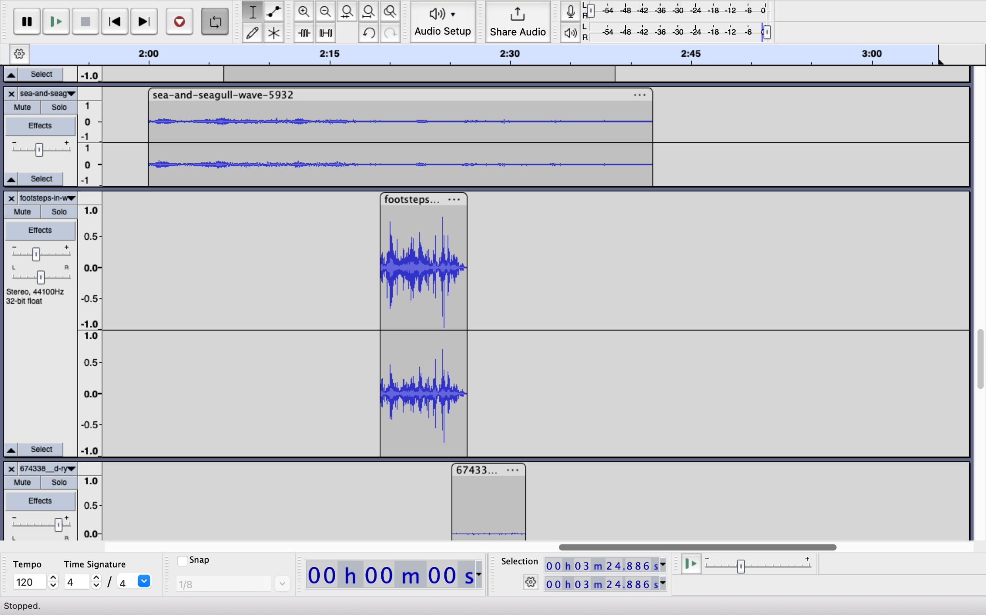

Screenshot 2: Using High/Low Pass

This image captures my use of the high pass tool to recreate the underwater portion, where the sounds above the water (families enjoying the beach and waves crashing) are muffled. In addition to talking about this tool in class, I played around with different values until I achieved a sound that I believe was realistic.

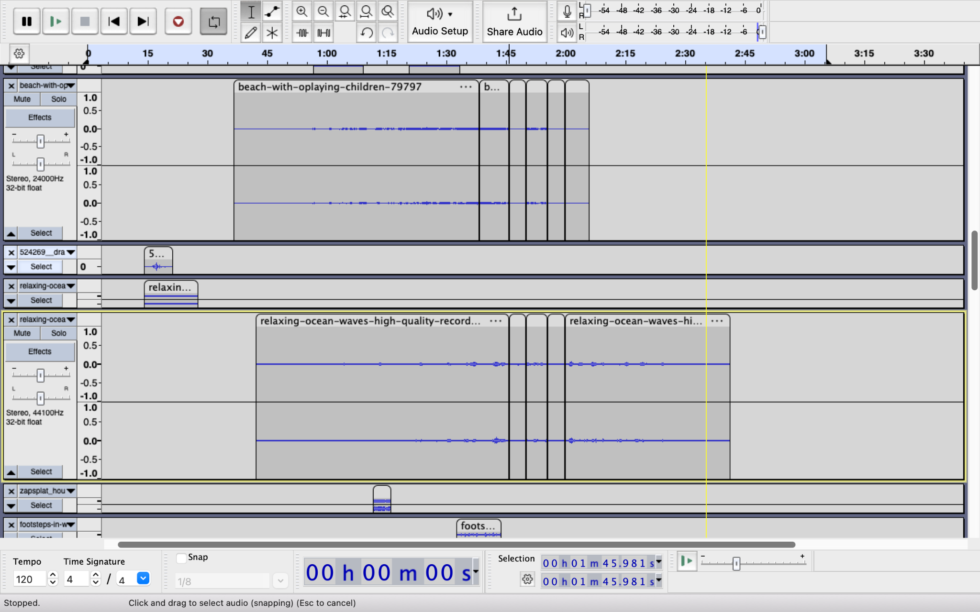

Screenshot 3: Using Amplifier Tool

This screenshot depicts the varying audio levels of the same audio clip. Here, the car music becomes quieter when the car window is down and then louder when the window scrolls back up. Although I used the amplifier tool to achieve this effect, I believe the experience would sound more realistic with a seamless adjustment rather than separated into different volumes. For the next version, I plan to use the fade in/out tool to create a more seamless volume transition.

